HQR Summer Ball ON-SCREEN ADVERTISING Booking Form 2024

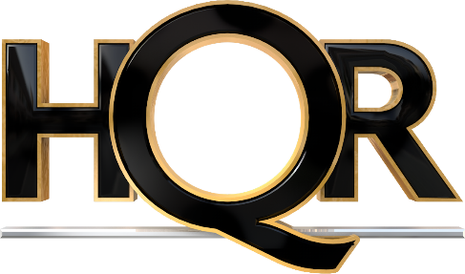

Please complete and return this booking form to Kelly Gower, HQR London Event Organiser: Kelly.Gower@HQRLondon.co.uk.

On-Screen advertising space is limited and is allocated on a first come, first served basis to hosts of tables at the 2024 HQR London Summer Ball only. Should space be available, your reservation will be confirmed by the issue of an invoice, payable within 7 days.

1. Booking Details
Company Name
We would like to purchase on-screen advertising space at the HQR Ball 2024 (please tick all that apply) | £250.00 | ☐
 | * Design Service @ £150.00 | ☐
 | On-Screen Advertising will be shown on the Great Room screens either side of the main stage during the evening. Purchasing on-screen advertising will provide your company with a dedicated slide comprising enhanced text and imagery.
Contact Name & Email

2. Requirements & Size Guide
- Artwork must be supplied to the correct sizing (3840pixels x 2160pixels) in Powerpoint format.
- Artwork to be received by HQR London NO LATER than Friday, 24th May 2024.
- Images should be to an acceptable size/resolution to be displayed in large format.
- HQR London takes no responsibility for the quality of image provided.

* HQR London can assist in the production of a simple on-screen apdvert design, if required, upon instruction and receipt of your company logo, any high-resolution images to be included and plain format text to be incorporated. Please tick the ‘additional design service’ box above if you would like to utilise this service.

3. Confirmation of Booking
We wish to confirm our on-screen advertisement booking as set out above and agree to provide artwork to the Event organiser no later than 24th May 2024. We understand that artwork provided after this date may not be included.
Signed |  | Date
Full name & position
On behalf of
(company name)

Please return your completed form to: Kelly.Gower@HQRLondon.co.uk

